# SECTION 2. ASSIGNMENT TASKS

## Task 0 – Database

@H:\INFS2200\seed2018.sql

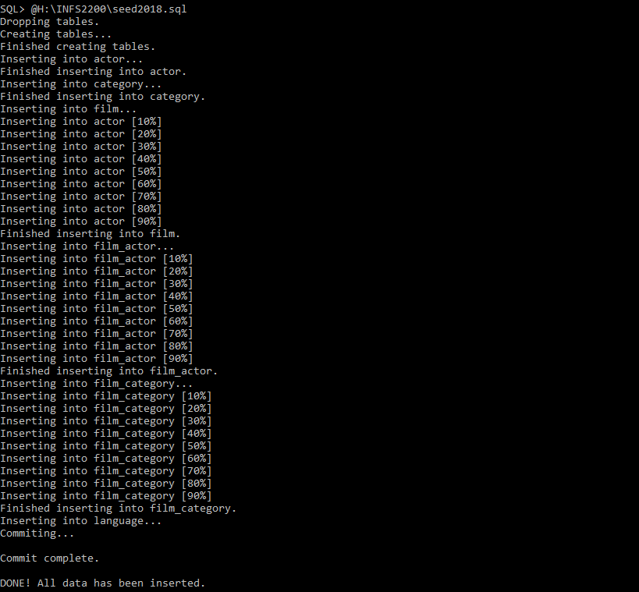

## Task 1 –Constraints

SELECT CONSTRAINT_NAME FROM USER_CONSTRAINTS;

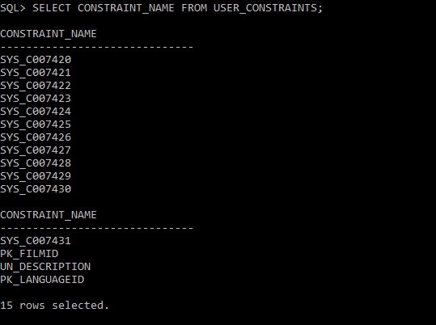

ALTER TABLE ACTOR ADD CONSTRAINT PK_ACTORID PRIMARY KEY (actor_id);

ALTER TABLE category ADD CONSTRAINT PK_CATEGORYID PRIMARY KEY (category_id);

ALTER TABLE ACTOR MODIFY first_name CONSTRAINT CK_FNAME NOT NULL;

ALTER TABLE ACTOR MODIFY last_name CONSTRAINT CK_LNAME NOT NULL;

ALTER TABLE FILM MODIFY title CONSTRAINT CK_TILE NOT NULL;

ALTER TABLE CATEGORY  MODIFY name CONSTRAINT CK_CATANAME NOT NULL;

ALTER TABLE FILM  MODIFY rental_rate CONSTRAINT CK_RENTALRATE NOT NULL;

ALTER TABLE FILM ADD CONSTRAINT CK_RATING CHECK ((rating = 'G') OR (rating = 'PG') OR (rating = 'PG-13') OR (rating = 'R') OR (rating = 'NC-17'));

ALTER TABLE FILM ADD CONSTRAINT CK_SPLFEATURES CHECK ((special_features = 'Trailers') OR (special_features IS NULL) OR (special_features = 'Commentaries') OR (special_features = 'Deleted Scenes') OR (special_features = 'Behind the Scenes'));

ALTER TABLE FILM ADD CONSTRAINT FK_LANGUAGE FOREIGN KEY (language_id) REFERENCES language (language_id);

ALTER TABLE FILM ADD CONSTRAINT FK_ORLANGUAGEID FOREIGN KEY (original_language_id ) REFERENCES language (language_id);

ALTER TABLE FILM_ACTOR ADD CONSTRAINT FK_ACTORID FOREIGN KEY (ACTOR_ID) REFERENCES ACTOR (ACTOR_ID);

ALTER TABLE FILM ADD CONSTRAINT CK_RELEASEYR CHECK (RELEASE_YEAR <= 2018);

## Task 2 –Triggers

1. Write a trigger, named BI_FILM_ID that automatically populates the film_id when a new film is added. The sequence, named FILM_ID_SEQ, should start from 22,000 and increment by 2.

CREATE SEQUENCE "FILM_ID_SEQ" MINVALUE 2020 INCREMENT BY 2 START WITH 22000;

CREATE OR REPLACE TRIGGER "BI_FILM_ID"

 BEFORE INSERT ON "FILM"

 FOR EACH ROW

BEGIN

   SELECT "FILM_ID_SEQ".nextval INTO :NEW.FILM_ID FROM DUAL;

END;

 /

SHOW ERRORS;

2. Write an SQL trigger, that should be named BI_FILM_LANG, to append text to the description of every new film inserted into the database. It is based on the language (language_id) and the original language (original_language_id) of the film.

CREATE OR REPLACE TRIGGER "BI_FILM_LANG"

BEFORE INSERT ON "FILM"

FOR EACH ROW

DECLARE

  OL_NAME VARCHAR2(20);

  NL_NAME VARCHAR2(20);

  N_DES VARCHAR(295);

BEGIN

  IF ((:NEW.original_language_id IS NOT NULL) AND (:NEW.language_id IS NOT NULL)) THEN

    SELECT name INTO OL_NAME FROM LANGUAGE WHERE language_id = :NEW.original_language_id;

    SELECT name INTO NL_NAME FROM LANGUAGE WHERE language_id = :NEW.language_id;

    SELECT CONCAT(CONCAT(CONCAT('Originally in ', OL_NAME), '. Re-released in '), NL_NAME) INTO N_DES FROM DUAL;

    :NEW.description := CONCAT(:NEW.description, N_DES);

  END IF;

end;

/

SHOW ERRORS;

## Task 3 – Views

1. Write a SQL statement to find the ‘Comedy’ films with the longest running time. Your query should output the titles and lengths of the films.

SELECT title, length

FROM FILM

WHERE film_id IN (

SELECT film_id FROM FILM_CATEGORY WHERE category_id IN (

SELECT category_id

FROM CATEGORY

WHERE name = 'Comedy'))

AND LENGTH = (SELECT MAX(length) FROM FILM

WHERE film_id IN (SELECT film_id

FROM FILM_CATEGORY WHERE category_id IN (

SELECT category_id

FROM CATEGORY

WHERE name = 'Comedy')));

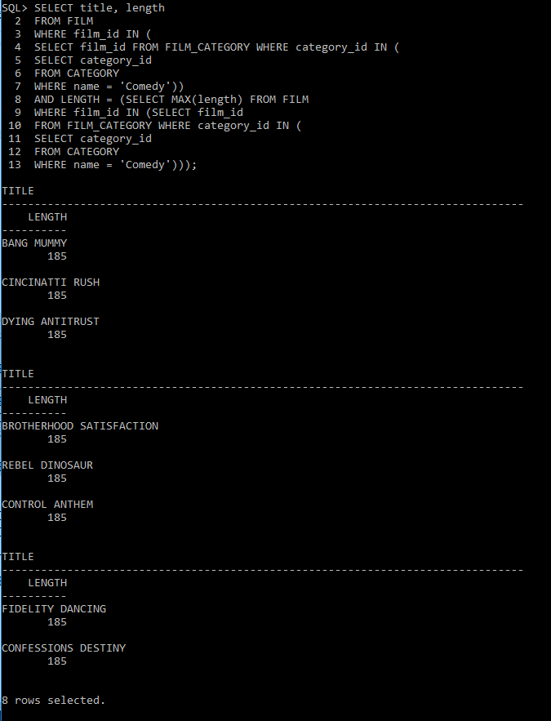

2. Write a SQL statement to create a (virtual) view called MAX_COMEDY_ACTORS that contains all the actors that have acted in the films that you obtained in Task 3.1. The view should include the columns actor id, first name and last name. Note: Actors may act in multiple films, but should only appear once in the view.

CREATE OR REPLACE VIEW MAX_COMEDY_ACTORS AS

SELECT * FROM ACTOR

  WHERE actor_id IN (SELECT actor_id

FROM FILM_ACTOR

   WHERE film_id IN (SELECT film_id

FROM FILM

WHERE film_id IN (

SELECT film_id FROM FILM_CATEGORY WHERE category_id IN (

SELECT category_id FROM CATEGORY WHERE name = 'Comedy'))

AND LENGTH = (SELECT MAX(length) FROM FILM

WHERE film_id IN (SELECT film_id

FROM FILM_CATEGORY WHERE category_id IN (

SELECT category_id FROM CATEGORY WHERE name = 'Comedy')))));

3. Write a SQL statement to create a (virtual) view called V_COMEDY_ACTORS_2008 that lists the ids, first names and last names of any actors that starred in a Comedy film released in the year 2008. CREATE OR REPLACE VIEW V_COMEDY_ACTORS_2008 AS

SELECT first_name, last_name FROM ACTOR WHERE ACTOR_ID IN (SELECT DISTINCT ACTOR_ID

                                                         FROM FILM_ACTOR WHERE film_id IN (SELECT FILM_ID FROM FILM

                 WHERE (release_year = 2008)

                 AND FILM_ID IN (SELECT film_id FROM FILM_CATEGORY WHERE category_id IN (

SELECT category_id

FROM CATEGORY

WHERE name = 'Comedy'))));

4. Write a SQL statement to create a materialized view called MV_COMEDY_ACTORS_2008 that lists the same information as in Task 3.3.

CREATE MATERIALIZED VIEW MV_COMEDY_ACTORS_2008

BUILD IMMEDIATE

AS

SELECT first_name, last_name FROM ACTOR WHERE ACTOR_ID IN (SELECT DISTINCT ACTOR_ID

                                                         FROM FILM_ACTOR WHERE film_id IN (SELECT FILM_ID FROM FILM

                 WHERE (release_year = 2008)

                 AND FILM_ID IN (

SELECT film_id FROM FILM_CATEGORY WHERE category_id IN (

SELECT category_id

FROM CATEGORY

WHERE name = 'Comedy'))));

**TASK3.5**

SELECT * FROM V_COMEDY_ACTORS_2008;

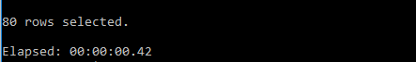

SELECT * FROM MV_COMEDY_ACTORS_2008;

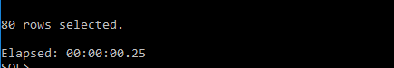

The first one is virtual view, and it takes longer time to query. A view uses a query to pull data from the underlying table. But when we creating Materialized view, it will create two objects, and it will physically store the view and its data. So that, in this case, the virtual view takes much longer time than materialized view.

## Task 4 – Indexes

SELECT title FROM (SELECT TITLE FROM FILM

WHERE (INSTR(SUBSTR(description, INSTR(description, 'in ')), 'Boat') != 0)

ORDER BY title ASC)

WHERE ROWNUM <= 200;

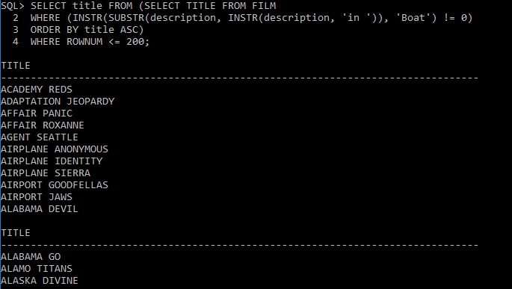

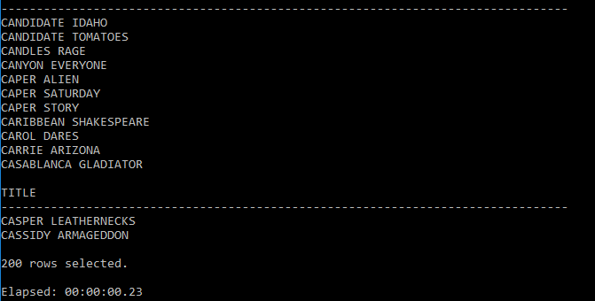

TASK 4.2

CREATE INDEX IDX_SEARCH_LOCATION ON FILM(INSTR(SUBSTR(description, INSTR(description, 'in ')), 'Boat'));

SELECT title FROM (SELECT TITLE FROM FILM

WHERE (INSTR(SUBSTR(description, INSTR(description, 'in ')), 'Boat') != 0)

ORDER BY title ASC)

WHERE ROWNUM <= 200;

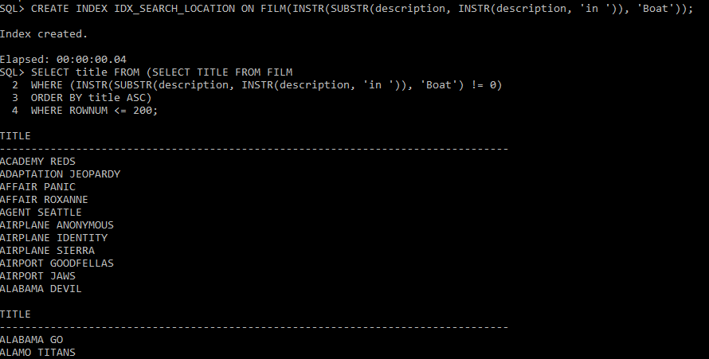

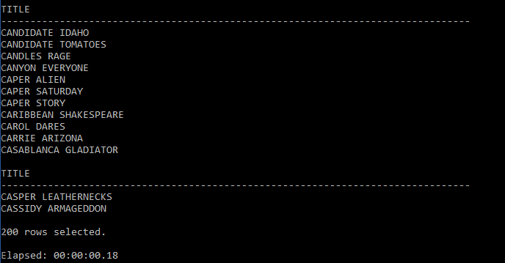

Since we using functions to analysis each description costs time for searching each row. Hence, we create function-based index to reduce analysis time

TASK4.3

Without index:



With index:



It is clearly that, the query with index will be faster than without index. An index is a data structure that stores the values for a specific column in a table.

## Task 5 – Execution Plan

TASK 5.1

EXPLAIN PLAN FOR SELECT /*+RULE*/ * FROM FILM WHERE FILM_ID > 1000;

SELECT PLAN_TABLE_OUTPUT FROM TABLE (DBMS_XPLAN.DISPLAY);

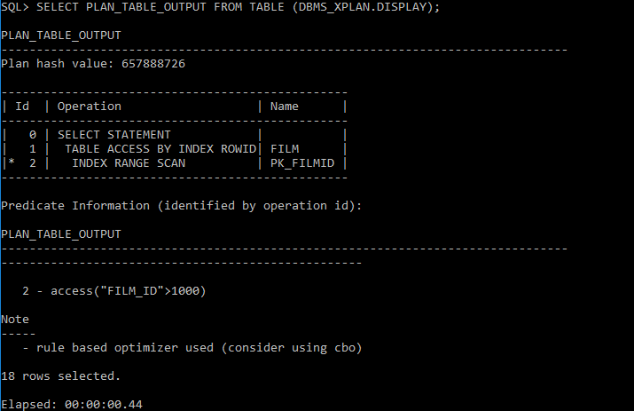

The Rule-Based Optimizer is a set of rules to determine how to execute a query. If there is an index, then the Rule-Based Optimizer will use this index to search.

INDEX (UNIQUE SCAN) - Index PK_FILMID is used in a unique scan operation to evaluate the WHERE clause criteria. It returns exactly one row id from the index.

• TABLE ACCESS BY INDEX ROWID - Rows are located using index; note that full table is not accessed as in the previous case.

• The SELECT statement returns rows satisfying the WHERE clause conditions.

• Cost–It shows the cost of the operation as estimated by the optimizer's query approach, which is a weighted value used to compare costs of execution plans. The value of this column is a function of the CPU_COST and IO_COST columns. It does not have any particular unit of measurement.

• Bytes–It represents the number of bytes accessed by the operation, as estimated by the query optimization approach.

• Time – It depicts elapsed time in seconds of the operation as estimated by query optimization.

TASK 5.2

EXPLAIN PLAN FOR SELECT * FROM FILM WHERE FILM_ID > 1000;

SELECT PLAN_TABLE_OUTPUT FROM TABLE (DBMS_XPLAN.DISPLAY);

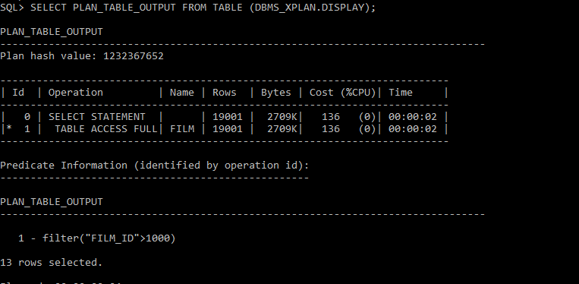

Cost-based optimizer is better than rule-based optimizer. Since the CBO determines which execution plan is most efficient by considering available access paths and by factoring in information based on statistics for the schema objects accessed by the sql statement.

TASK 5.3

EXPLAIN PLAN FOR SELECT * FROM FILM WHERE FILM_ID = 1000;

SELECT PLAN_TABLE_OUTPUT FROM TABLE (DBMS_XPLAN.DISPLAY);

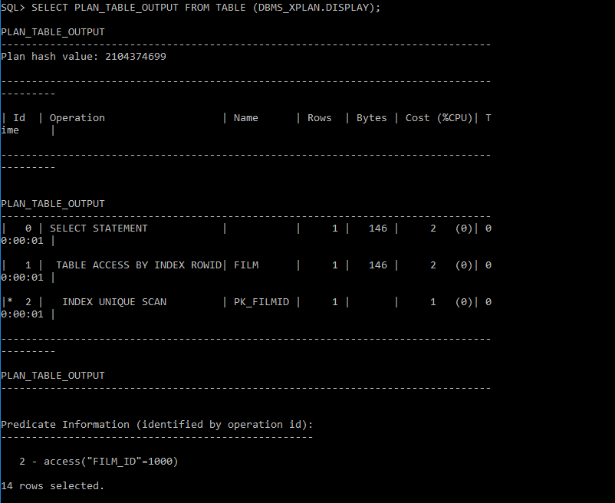

TASK 5.4

Task 5.1 used Rule-based optimizer, index PK_FILMID is used to access the data which FILM_ID is greater than 1000 in FILM table. Hence, FILM tables are not fully accessed. In task 5.2, table is fully accessed, all records are scanned.

Task 5.5

In task 5.2, all records in FILM are scanned, since task 5.2 wants to generate the data which FILM_ID is bigger than 1000. But in task 5.3, index PK_FILMID is used in unique scan, so just one record is returned.

TASK 5.6.A

ANALYZE INDEX PK_FILMID VALIDATE STRUCTURE;

SELECT HEIGHT FROM INDEX_STATS;

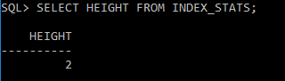

TASK 5.6.B

ANALYZE INDEX PK_FILMID VALIDATE STRUCTURE;

SELECT LF_BLKS FROM INDEX_STATS;

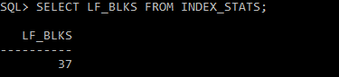

TASK5.6.C

SELECT BLOCKS FROM USER_TABLES WHERE TABLE_NAME = 'FILM';

